SYNOPSIS OF PROJECT WORK

BLIND ASSIST – CURRENCY IDENTIFICATION SYSTEM
Project By:
Submitted To:

1. Project Overview
This document outlines the software requirements and design synopsis for Blind Assist, a computer-vision-based assistive technology application. The primary objective is to empower visually impaired individuals to identify Indian currency notes independently.
The system utilizes a live camera feed to capture images of currency, which are processed by a trained Convolutional Neural Network (CNN). The model classifies the notes into specific denominations (₹10, ₹20, ₹50, ₹100, ₹200, ₹500, and ₹2000). Crucially, the identification result is immediately converted into an audio cue, ensuring a completely hands-free and vision-independent experience.
Technology Stack:
- Language: Python
- Web Framework: Django
- Image Processing: OpenCV
- Deep Learning: TensorFlow / Keras (DenseNet Architecture)
- Audio Output: Text-to-Speech Engine (e.g., pyttsx3 or gTTS)

2. Major Functional Capabilities
The system is designed with a focus on accessibility and speed. Key functionalities include:
- Real-time Acquisition: Instant image capture via webcam integration.
- AI-Powered Classification: High-accuracy detection using deep learning.
- Auditory Feedback: Immediate voice announcement of the denomination.
- User-Centric Interface: A simplified web interface built on Django.
- Offline Capability: capable of running locally without continuous internet access after deployment.

3. Component Description & System Modules

UNIT-01: System Architecture
This unit defines the structural layout and data flow of the Blind Assist system.

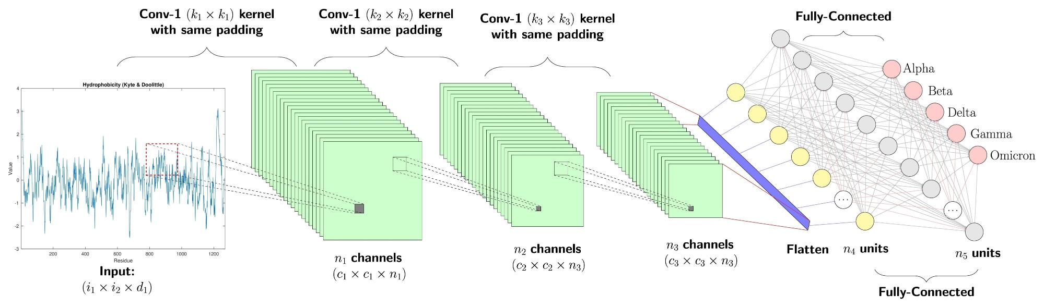

The architecture consists of four distinct modules:
- Image Input Module: Leverages OpenCV to access hardware (webcam) and capture video frames.
- Preprocessing Layer: Algorithms resize, normalize, and augment images to match the input tensor shape required by the CNN.
- Classification Model: A DenseNet-based CNN serves as the core engine, analyzing visual patterns to predict the currency class.
- Output Generation Module: The predicted label is passed to the TTS engine, generating an audio waveform (e.g., "Five Hundred Rupees").

UNIT-02: Purpose and Scope
Purpose:
To bridge the accessibility gap for visually impaired users by providing a reliable tool for financial autonomy.
Scope:
- Denomination Coverage: Supports current circulation of Indian banknotes.
- Deployment: Local host deployment via a web browser.
- Nature: Assistive utility (Note: Not intended for counterfeit detection/banking-grade validation).

UNIT-03: System Perspective
This unit describes the environment in which the system operates.
- Standalone Application: The system runs on the client machine (PC/Laptop).
- Interaction Model: Minimal interaction required; the system prioritizes automated detection over manual input.
- Target Audience:
  - Primary: Visually impaired or elderly individuals.
  - Secondary: Developers and maintainers.

UNIT-04: Requirement Analysis
Functional Requirements:
- The system must interface successfully with standard USB or integrated webcams.
- The inference time (time to predict) must be low to ensure usability.
- Audio output must be clear and distinguishable.
Non-Functional Requirements:
- Usability: Interface must be navigable via keyboard shortcuts or screen readers.
- Robustness: Model should maintain accuracy under varying lighting conditions and note orientations.
- Scalability: The architecture should allow for the addition of new currency notes in the future.

UNIT-05: Process Flow (Operational Sequence)
The logical flow of the application is as follows:
- Initialization: User launches the Django web server and opens the interface.
- Capture: User presents the note to the camera; the system captures the frame.
- Preprocessing: Image is converted to RGB, resized, and normalized.
- Inference: The CNN model calculates the probability for each currency class.
- Decision: The class with the highest probability is selected.
- Feedback: The system converts the text label to speech and plays the audio.

4. Development Schedule
The project execution is divided into four strategic phases:

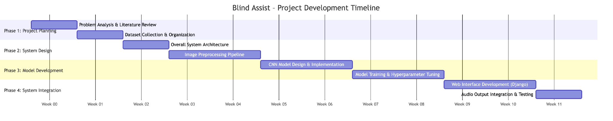

Phase | Activity | Description
Phase 1 | Planning & Analysis | Literature survey, dataset collection, and feasibility study.
Phase 2 | Architecture Design | Completion of UNIT-01 & UNIT-02. Setting up the Django environment and preprocessing pipelines.
Phase 3 | Model Training | Completion of UNIT-03. Training the DenseNet model, validation, and hyperparameter tuning.
Phase 4 | Integration & Testing | Completion of UNIT-04 & UNIT-05. Integrating the model with the web UI, adding audio modules, and final testing.

